# Business Problem:

The Cardio Vascular Metabolic (CVM) diseases are a cluster of conditions and risk factors that increase the likelihood of developing heart disease, stroke, and/or type 2 diabetes. The impacts of CVM diseases on people, society and our planet are immense and growing, yet they remain underdiagnosed, undertreated and their interconnections under-recognised. These conditions affect hundreds of millions of people around the world; we estimate that one in three people with a CVM disease are living with two or more of these chronic diseases. The improved healthcare and awareness has influenced the death rates. Thus, the deaths related to cardiovascular disease (CVD), such as coronary heart disease, stroke, and hypertension, have declined. The connected mortaility rates have declined by 36% during 14 years from 2000 to 2014. Howerver, this rate has been slowed down since 2011. (Nilay S. Shah, Donald M. Lloyd-Jones, Martin O’Flaherty, & al, 2019)

Metabolic conditions linked to CVM diseases, such as obesity and diabetes, are increasingly prevalent. In recent years, approximately 50% of U.S. adults were found to have at least one cardiometabolic condition, with racial disparities evident. (National Health and Nutrition Examination Survey (NHANES))

Thus, it has become imperative to look and explore the trends in claim data of patients related to CVM dieases and give some useful business insights.

#### Steps for analyzing data

The steps usually involve cleaning and sorting of the data

* Firstly, a new binary variable called ‘cardiac_flag’ has been created with 1 for CVM related claims and 0 for Non-CVM claims based on the ‘category’ column/attribute within hcpcs_code_100_df dataframe.
* After that the two dataframes: hcpcs_code_100_df and medicare_df are merged based on hcpcs_code.
* Then the null values were removed based on cardiac_flag
* Made sure that the data is filtered for the years 2016 – 2018.
* Then removed the non-procedural categories like ‘Administrative’ and ‘other’s’.
* The null values for npi_id were also removed.
* At last, the duplicate values were dropped based on the claim_id.

Assumptions

The analysis has been done based on the assumption that the actual data is more detailed and rigrous as compared to the Syntegra data

# Exploratory Data Analysis and Insights:

### **CVM claims 2016 - 2018**

The total CVM claims share for the year 2016 to 2018 are 26.12%, 26.15% and 25.08%, respectively. This shows a very steady trend over the period. We can see a slight decrease in the year 2018. This can be the consequence of awareness and health improvement, or it may be due to the fact that more people have started to cover their medical expenses out=of-the-pocket.

To explore the actual cause, some of the statistics needed to be stated. The trend of claims related to cardiovascular metabolic (CVM) diseases in the U.S. has shown significant growth due to rising prevalence, especially as overlapping conditions like cardiovascular disease (CVD), chronic kidney disease (CKD), and diabetes increase. These conditions frequently co-occur, particularly among older adults, with overlapping conditions almost doubling from 5.3% in 1999 to 8.0% by 2020. (Ostrominski, et al., 2023) Additionally, the number of U.S. adults with all three conditions rose from 0.7% to 1.5% over this period, indicating an upward trend in multimorbidity (having more than one chronic condition simultaneously) linked to CVM diseases​. (John W., et al., 2023) Thus, this slight increase and then decrease may be due to factors such as out-of-pocket payments and insurance variations. The reasons for the out-of-pocket payments might include high deductible health plans, gaps in coverage, or limited insurance benefits for specific treatments. Moreover, changes in health insurance policies, such as increased co-pays, limited coverage for certain CVM medications or treatments could lead patients to delay or reduce care for CVM issues. If the share of CVM claims slightly increased from 2016 to 2017 and then decreased from 2017 to 2018, this could also indicate changes in patient demographics, health awareness, or lifestyle pattern baseds.

We will look at the claim amount for each year.

The above graph clearly shows the increase in the claim cost over the time. This can be one of the reasons stated above for increased out-of-pocket expenses.

The pharmaceutical companies can work with the US government and other payer organizations to increase the coverage range of medical expenses.

### **HCP behavior in context of claim volume from 2016-2018**

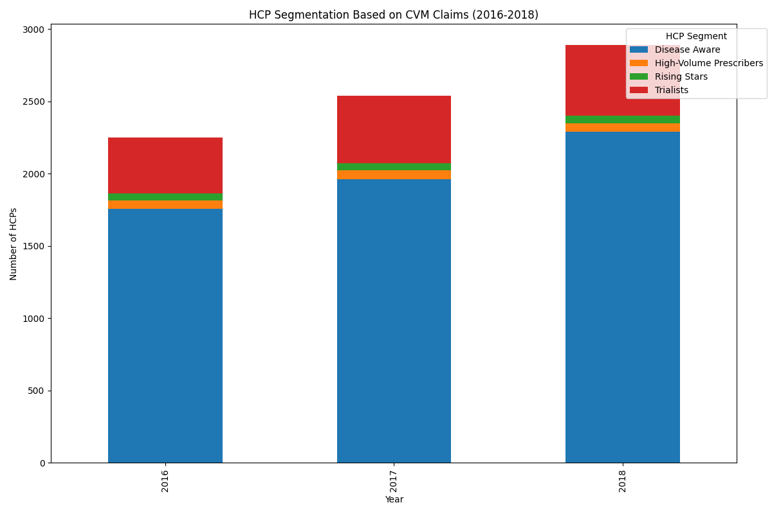

The above figure shows that there mostly are disease aware HCPS (having one claim) and their number is also increasing every year. After that there are trialists (HCPs with 2-4 CVM claims). There is a very small proportion of Rising Stars (HCPs with 5-9 CVM claims) and High-Volume Prescribers (HCPs with 10+ CVM claims).

First of all, the sales teams should investigate the disease aware HCPS whether they are new doctors, or they have started to prescribe the competitor’s medications. If they are new doctors the sales team should make follow-up visits to them to encourage them to prescribe the product. The sales team should also see the Trialists. In this way the disease aware and the Trialists will fall in Rising stars and High-volume prescribers. The ultimate goal is to have maximize the number of High-volume prescribers.

The sales and marketing teams should further look into the channels which are used to target the HCPS and improve them. If the company is already targeting the HCPs using in-Person (sales force) that the sales force team should be in the limelight and trained more to attract the disease aware and Trialists more. If the company is using Non-Personal Promotions (NPP, i.e. Emails, Social Media, Digital etc.) then it should focus on this. The suggestion would be to adopt the omni-channel strategy.

### **Patient age demographics for the CVM claims**

Firstly, the number of total claims have increased over the year and the most frequent number of claims are by ages 60 – 69, 70 – 79 and 80+. This is logical because the heart disease risk increases with age. The percentage change also gives more useful insights. The percentage change is mostly positive which resonates with the convention that prevalence of disease is increasing. The percentages are high for patients with 79 – 80 years. The percentage change for the 80+ patient for the year 2017 is negative which further needs to be investigate and for 2018, it is showing maximum increase of around 40%.

The useful takeaway for the pharmaceutical companies is to increase the number of people older than 60 years for insurance coverage. The pharmaceutical companies can influence the government to increase the range of Medicare and Medicaid.

The risk of CVM disease is high also among the people of low income because of their lifestyle and food consumption patterns. Thus, Medicaid will help in the coverage of these types of patients.

The company can come up with more detailed advertising campaigns for their medications for elderly patients.

# Conclusion:

It can be observed that the claims for the three years are showing a steady and very slight growth for the given observed years from 2016 – 2018. So, the pharmaceutical companies really need to investigate the actual cause of this and work with the payers. The pharma company should also strengthen their sales force team and observe other sales and marketing strategies to target their customers.

For the CVM claims the annual growth rate of CVM claims as a percentage of total claims can be calculated. Analyzing these growth rates can reveal whether the trend is accelerating, decelerating, or stable, helping in forecasting future trends more accurately. By assessing monthly or quarterly data, the seasonality patterns in the CVM claims can be analyzed.

#### Further analysis using the whole data:

Further, the more recent data after 2018 can be incorporated to observe the recent trends. We can also investigate medication adherence trends across age groups in the claims data. Analyze claims data to identify whether particular demographics are more likely to have recurring claims or require additional medications for comorbidities. This could inform research into tailored drug efficacy or formulation adjustments by subgroup, potentially improving treatment outcomes. The claims for out-patient and in-patient claims can also be investigated to understand where pharmaceutical should focus.

At last, we can use predictive analytics to forecast demand for CVM-related drugs by analyzing trends in patient demographics, claim volumes, and related conditions. This can guide R&D investment, production planning, and strategic marketing to address future needs effectively.

# Works Cited

John W., O., Suzanne, V. A., Javed, B., Gregg C., F., Jamie S., H., Swetha, P., . . . Eric B. Collins, J. J. (2023, September 27). *Prevalence and Overlap of Cardiac, Renal, and Metabolic Conditions in US Adults, 1999-2020*. Retrieved from AbleSci.COM.

Nilay S. Shah, M. M., Donald M. Lloyd-Jones, M. S., Martin O’Flaherty, M. M., & al, e. (2019, August 27). *Trends in Cardiometabolic Mortality in the United States, 1999-2017*. Retrieved from JAMA Network Home: https://jamanetwork.com/journals/jama/fullarticle/2748780

Ostrominski, J. W., Arnold, S. V., Butler, J., Fonarow, G. C., Hirsch, J. S., Palli, S. R., . . . Vaduganathan. (2023, September 27). *Prevalence and Overlap of Cardiac, Renal, and Metabolic Conditions in US Adults, 1999-2020*. Retrieved from Deepdyve: https://www.deepdyve.com/lp/american-medical-association/prevalence-and-overlap-of-cardiac-renal-and-metabolic-conditions-in-us-urhOWM7sBb

ChatGPT